Welcome to Great Hockham Primary and Nursery School!

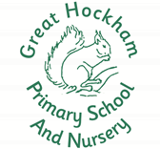

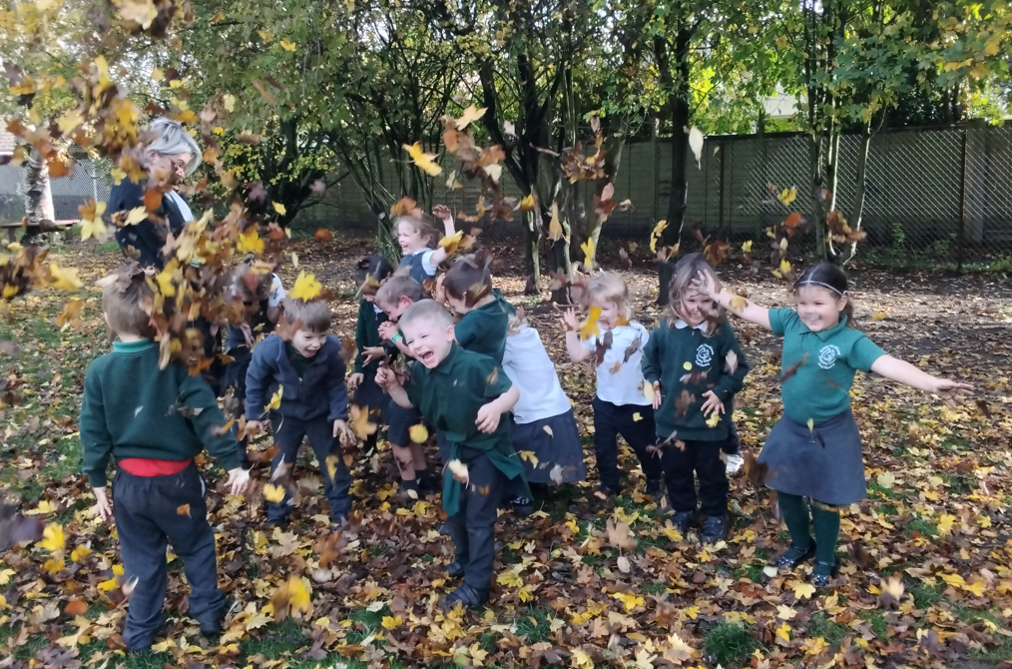
Who WWEW
We are all here to help:

Headteacher Mrs Hazard

Rabbit Class Teacher Miss Bryan

Teaching Assistant Mrs Hayes

Teaching Assistant Mrs Shiplee
(morning sessions) Mrs Searle

Office Administrator Mrs Jones
Office Assistant Mrs Pavey

SENDCo Miss Rawcliffe

In this booklet you will find general information. There is more information on our website in the Rabbit Class section.

We look forward to you joining our wonderful school. If you have any further questions, please do not hesitate to contact us;

Email: office@hockham.set.education
Telephone: 01953 498302
A Day in Rabbit Class
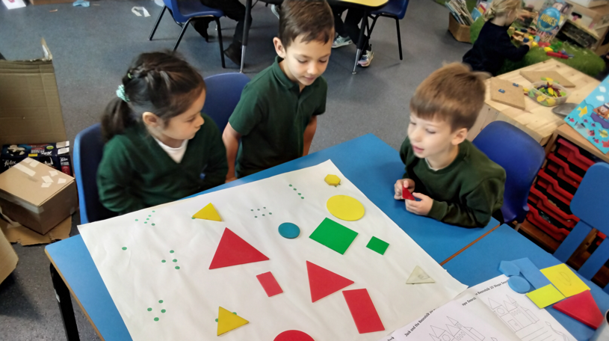

8:45: Door opens

9:00: Register
9:10: Phonics
9:30: Continuous provision
10.20 Snack, language skills.
10:45: Maths carpet input
11:00: Continuous provision
12:00: Lunch/Nursery morning session ends
1:00 Afternoon session/register
1:05: English/ Understanding of the World carpet session
1:20 Continuous provision
3:00 Story
3:15 Home time
During continuous provision, your child will have access to the indoor and outdoor environment. We know that children in the Early Years learn best through play and we provide these opportunities wherever possible.

When to arrive

Please arrive from 8.45am. The door closes at 9am. Please try to arrive by this time to provide your child the best start to the school day. At the end of the school day we will not release your child until we have seen you. You must give us prior instructions if somebody else is picking up your child. The school day ends at 3.15pm.

What to bring

Water
We will be providing a water bottle for every child, this will be left at school. This ensures your child has access to water throughout the school day.

Lunch
A letter will follow detailing lunch options, payment and ordering.

Book Bags
The school will be providing a book bag for each child. In this will be a reading record book and reading book.

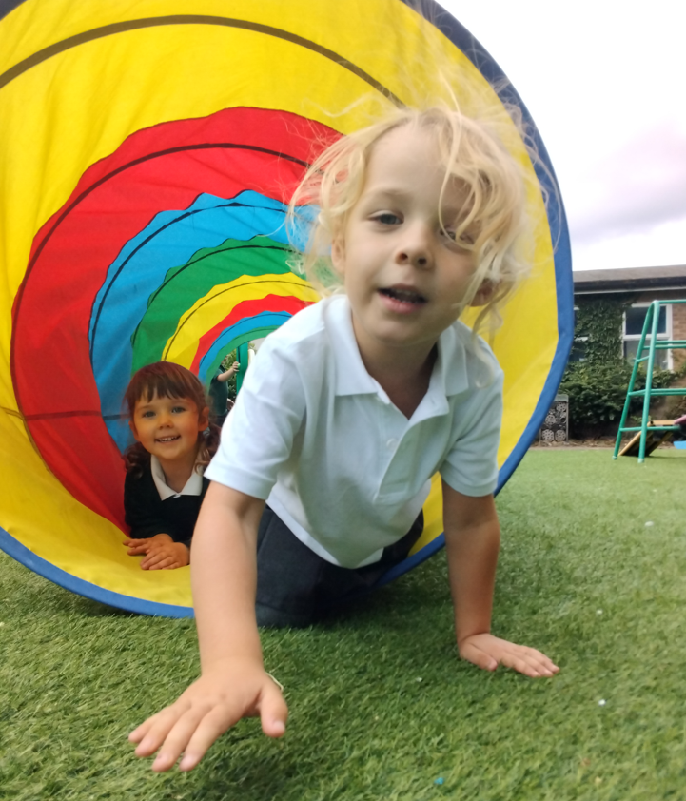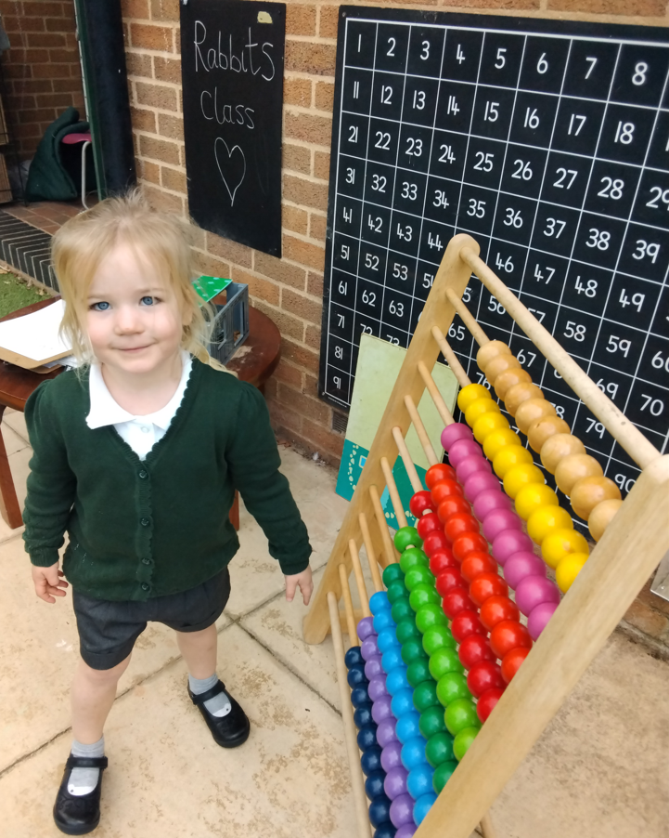

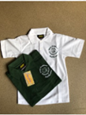

What to wear

School uniform
Top
White or green school logo polo shirt
Plain white or green polo shirt
Worn with either;
School logo sweatshirt
School logo cardigan
Plain green sweatshirt
Plain green cardigan
Bottoms
Charcoal grey skirt or pinafore
Charcoal grey trousers or shorts
Grey, green or black tights
Nursery only – plain black jogging bottoms
Or
Green gingham dress
Please note that leggings are not acceptable
Shoes
Black school shoes or unbranded plain black trainers
Wellies (these are to be left at school)

Items with the school logo are available from Birds of Dereham. You may order on-line or in-store. Other items are available from many supermarkets and department stores.

PE kit (please ensure each piece of clothing is named)
White t-shirt
Black shorts/ Black skort
Any suitable tracksuit bottoms/top for cold weather
Outdoor trainers
Please ensure each item of your child’s uniform is named.

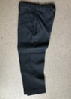

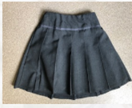

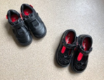

Our curriculum

Our Aims for children in Rabbit class are;
  - To provide a happy, safe, and stimulating environment
  - To support the growth and development of each child as an individual
  - To provide opportunities for children to learn alongside one another.
  - To provide experiences that further their physical development, foster their curiosity and imagination about the world they live in.
  - To build their confidence and help them feel good about themselves.
We are a mixed Nursery and Reception class. By having a mixed age class we can use our Early Years Foundation Stage curriculum as it is intended: “Children develop at their own rates, and in their own ways. The development statements (Early Years curriculum) and their order should not be taken as necessary steps for individual children.” (DfE, 2017).
This means we use the curriculum document to plan engaging and fun lessons but can differentiate according to your child’s needs- not the age band they fall within. This supports us to extend and guide learning opportunities.

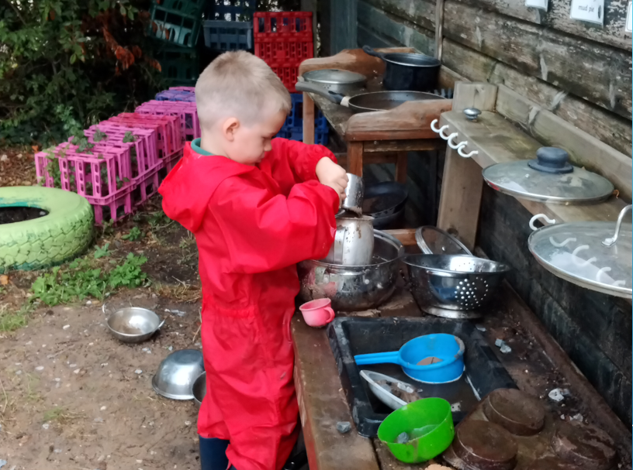

What is the Early Years Foundation Stage?

The Early Years Foundation Stage (EYFS) is a comprehensive Statutory framework published by the Department for Education on 3rd March 2017. The framework sets standards for learning, development and care for children from birth to five years. There are four themes to follow;
- A unique Child
- Positive Relationships
- Enabling Environments
- Learning and Development

All registered Early Years providers are required to use this framework and complete an EYFS profile for each child at the end of the academic year in which they reach five. During this stage children work towards ‘Early Learning Goals’. Most children will achieve or be well on their way to achieving the Early Learning Goals by the end of the Foundation Stage.

The 7 Areas of Learning and Development

3 Prime Areas:
Communication and language development involves giving children opportunities to experience a rich language environment; to develop their confidence and skills in expressing themselves; and to speak and listen in a range of situations.
Physical development involves providing opportunities for young children to be active and interactive; and to develop their co-ordination, control, and movement. Children must also be helped to understand the importance of physical activity, self-care and how to make healthy choices.

Personal, Social and Emotional development involves helping children to develop a positive sense of themselves, and others, to form positive relationships and develop respect for others, to develop social skills and learn how to manage their feelings, to understand appropriate behaviour in groups and to have confidence in their own abilities.

These three areas are particularly crucial for igniting children’s curiosity and enthusiasm for learning, and for building their capacity to learn, form relationships and thrive. Therefore, we place a strong emphasis on these for our Nursery children.

Specific Areas

Literacy development involves encouraging children to link sounds and letters and to begin to read and write. Children must be given access to a wide range of reading materials (books, poems, and other written materials) to ignite their interest.
Mathematics involves providing children with opportunities to develop and improve their skills in counting, understanding and using numbers, calculating simple addition and subtraction problems and to describe shapes, spaces, and measures.
Understanding the world involves guiding children to make sense of their physical world and their community through opportunities to explore, observe and find out about people, places, technology and the environment.
Expressive arts and design involves enabling children to explore and play with a wide range of media and materials, as well as providing opportunities and encouragement for sharing their thoughts, ideas and feelings through a variety of activities in art, music, movement, dance, role-play, and design and technology.

The 3 Prime Areas are essential to ensure children can make progress in these 4 Specific Areas of Learning.

Characteristics of Effective Learning (The Way Children Learn)

Through effective planning and guidance during activities the children will learn to display the following:-

Playing and exploring - to investigate and experience things, and ‘have a go’.

Active learning - to concentrate and keep on trying if they encounter difficulties and enjoy achievement.

Creating and thinking critically - to have and develop their own ideas, make links between ideas and develop strategies for doing things.

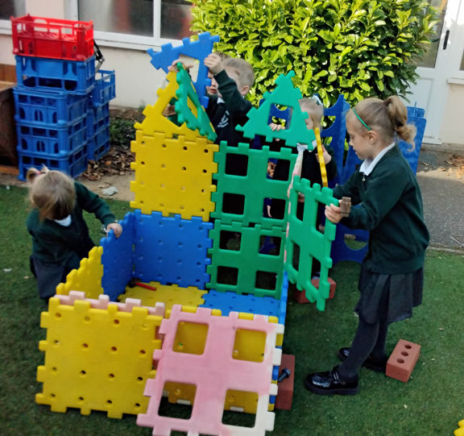
Child Initiated Activities
Well planned play is an important way in which children learn with enjoyment and challenge during the Foundation Stage. For much of the school day children will choose how they play with the educational resources/toys available. This is known as child-initiated play. The children are leading their own learning and during this time the practitioners use their expertise to develop children’s ideas and encourage children to work together.

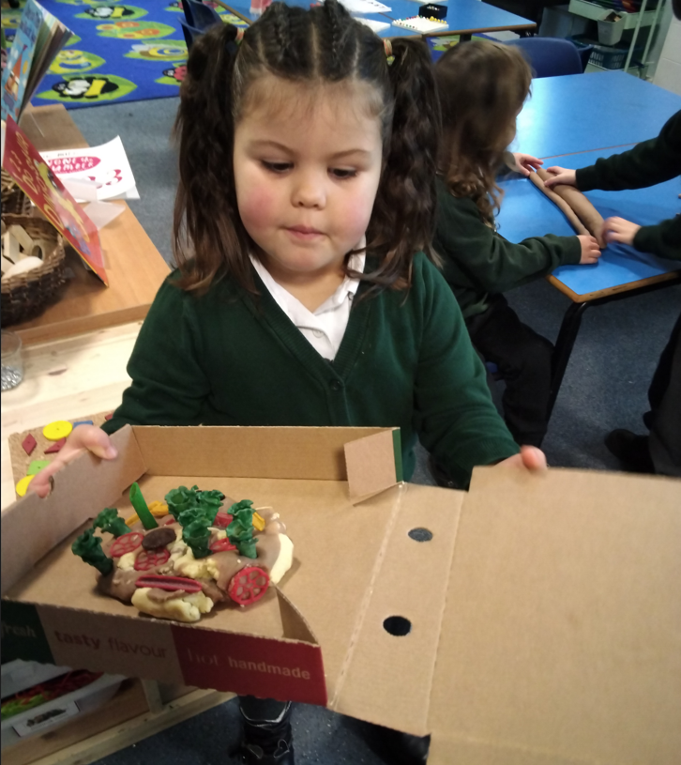
Adult Led Activities
There will be time allocated each day for adult led tasks. This may be as a whole class or in small groups. The Early Years staff set up and lead an activity desired to fulfil certain learning objectives and develop skills.

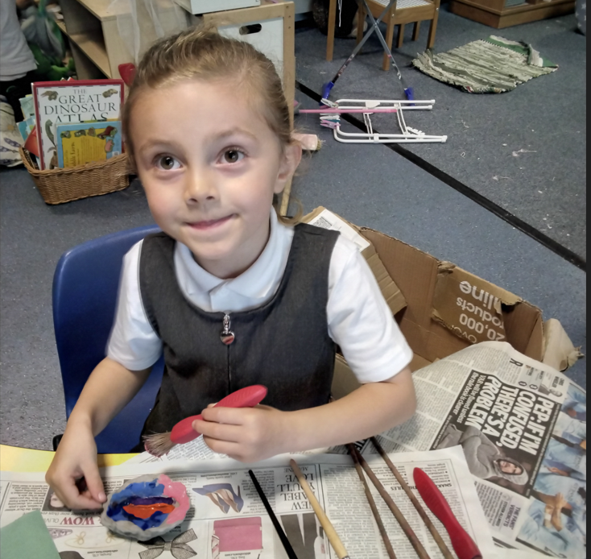

How to help your child
Linked to the 3 Prime Areas of learning listed above we encourage the children to be independent in the following areas;
-Toileting
-Dressing/ Undressing (for PE)
-Changing their shoes e.g. for wellies
-Putting on and doing up their own coat (buttons and zips)
-Being responsible for other belongings such as hats and gloves.
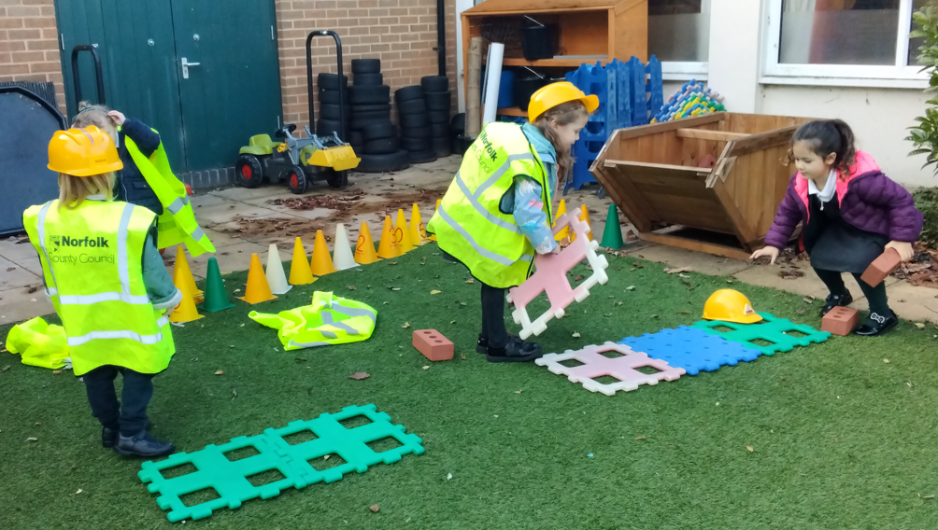
Learning Journey
Throughout their time in Rabbit class, your child will have their online learning journey recorded via Tapestry. There will be a Tapestry letter to follow with further details and a permission slip. Staff in the class will add observations of your child’s learning and development. There is also the option for you to add your own observations of learning from home.
Phonics

We follow the government recommended Letters and Sounds programme Little Wandle at Great Hockham Primary and Nursery. As a school we recognise the importance of early reading. Because of this we provide a daily phonics session for every child. These are different for Nursery and Reception children. Nursery will focus on Phase 1 and 2 and Receptions work through Phases 2-4. This is then continued with Phase 5 in Year 1.

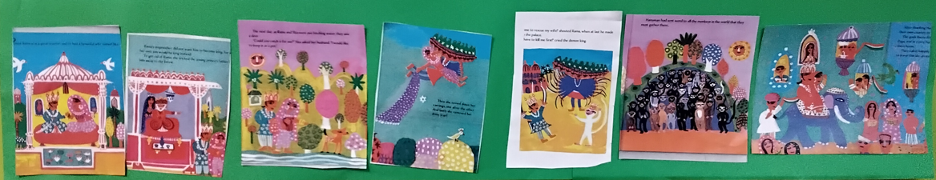

English

At Great Hockham we foster a love of reading. Your child will be read to daily as well as having the opportunity to share a book 1:1 with an adult daily. In Reception, your child will have ‘Words of the Week’ each week. These are High Frequency words required for children to know by the end of year 1. They are words that cannot be decoded, unlike our phonics sessions where we focus on words that can be blended (read) and segmented (spelt to write).
Maths
It is said that maths is everywhere! This is a statement we agree with whole heartedly at Great Hockham. The children access maths activities daily through our continuous provision. We also have daily lessons based on White Rose Maths, a Maths Mastery approach.

Funky fingers

These sessions are to support fine motor skills, which are vital when learning to write. Please refer to the school website under Rabbit Class for more details.

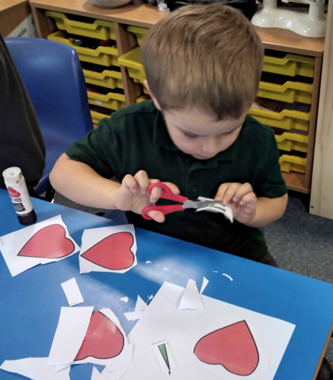

Parents as partners
At Great Hockham we value our relationship with our children and parents. Throughout the year there will be opportunities for you to visit the classroom through home learning exhibitions, for example.
We also:
- Hold parents’ evenings in the autumn and spring term where we share your child’s progress with you.

- In the Summer term we provide a written report detailing your child’s achievements in relation to the Characteristics of Effective Learning, the Early Learning Goals and their next steps.

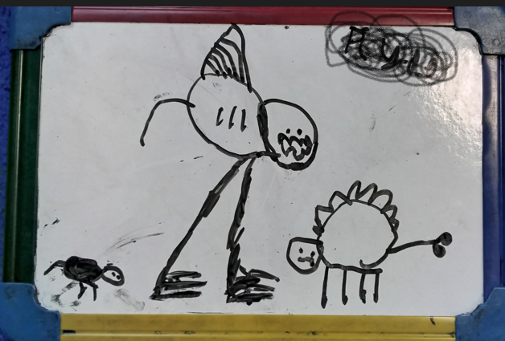
We sincerely look forward to welcoming you to our school!

