Science club at school!!

At school every Wednesday we do a science club to collect stickers and get a certificate. The science ambassadors run it and the science ambassadors are: Archie, Tomas, Max B, Rachel and Isobel.

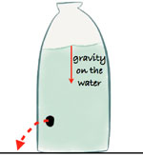Last Wednesday we did an experiment called a hole in my bucket, which was really fun basically what we had to do was mend a hole in the bottom of a milk carton with these materials: Felt, tape like double sided tape and normal tape we had some straws and timers, and we had to see how may seconds the water stayed in the milk carton and not leak out.

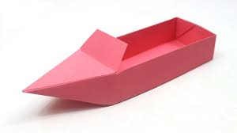Two days ago we did an experiment called raft crafting where we had to build a raft with these materials: Paper we were allowed six pieces per pair and tape, you might be wondering how will you build a raft with only tape and paper and actually it is quite easy you just to tape or glue a few pieces of paper together, and then we had to put marbles on the raft we made and see how many marbles you can put on the raft before it sinks. I thought this was really fun because I love science and I want to become a scientist when I grow up!!

By Mollie Mckinnel